Name:- Reshma Shaik

Roll No:- 21NN5A0507

Email:- shaikreshma1508@gmail.com

College Name:- Vignan’s Nirula Institute of Technology and Science For Women

**DATA SET:**

**SAMPLE-SUPERSTORE.XLS**

**TASK**

**Assignment-4**

Task 1:- Create one fixed and one exclude LOD expression.

Task 2: Create any 2 map visualizations using geographical data.

Task 3: Create Top N and/or Dynamic dimension parameters and utilize those in your workbook.

**Explain LOD Expression, Map Visualizations using geographical data and Top N,**

**Dynamic dimension Parameters**

LOD Expression :- **Level of Detail (LOD) expressions** are used to run complex queries involving many dimensions at the data source level instead of bringing all the data to Tableau interface.

Different types of LOD functions :-

There are three types LOD functions:-

1. Fixed
2. Include
3. Exclude

Map Visualization using geographical data :-

Tableau is a tool for analyzing geographical data. It can automatically turn location data into interactive maps.

ZOOM Levels :- 16

In Map Visualization, Geographical fields are double click on the field the data pane and tableau will create a map using generated latitude and longitude fields.

Top N Parameter:-

Top N parameter uses a value selected by the user, where N is a value. The value can be static or controlled by a parameter.

Top N parameter is also known as Bottom N.

Tableau allows users to filter and display a certain percentage of their data.

Dynamic Dimension Parameters:-

Create a Parameter. Create a new Parameter that lists your dimensions.

Create a Calculated field that will be used as a dimension in your worksheet. Dimension to display when a particular parameter value is selected.

Add the calculated fields to the canvas.

1. Colours
2. Filters
3. Select any ratings or price ranges.

Tableau Starting:-

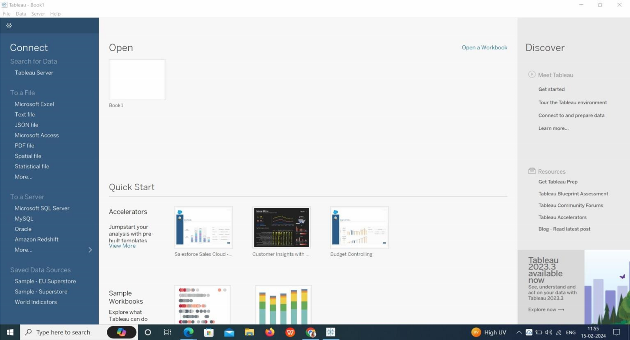

Upload the DataSet in Tableau:-

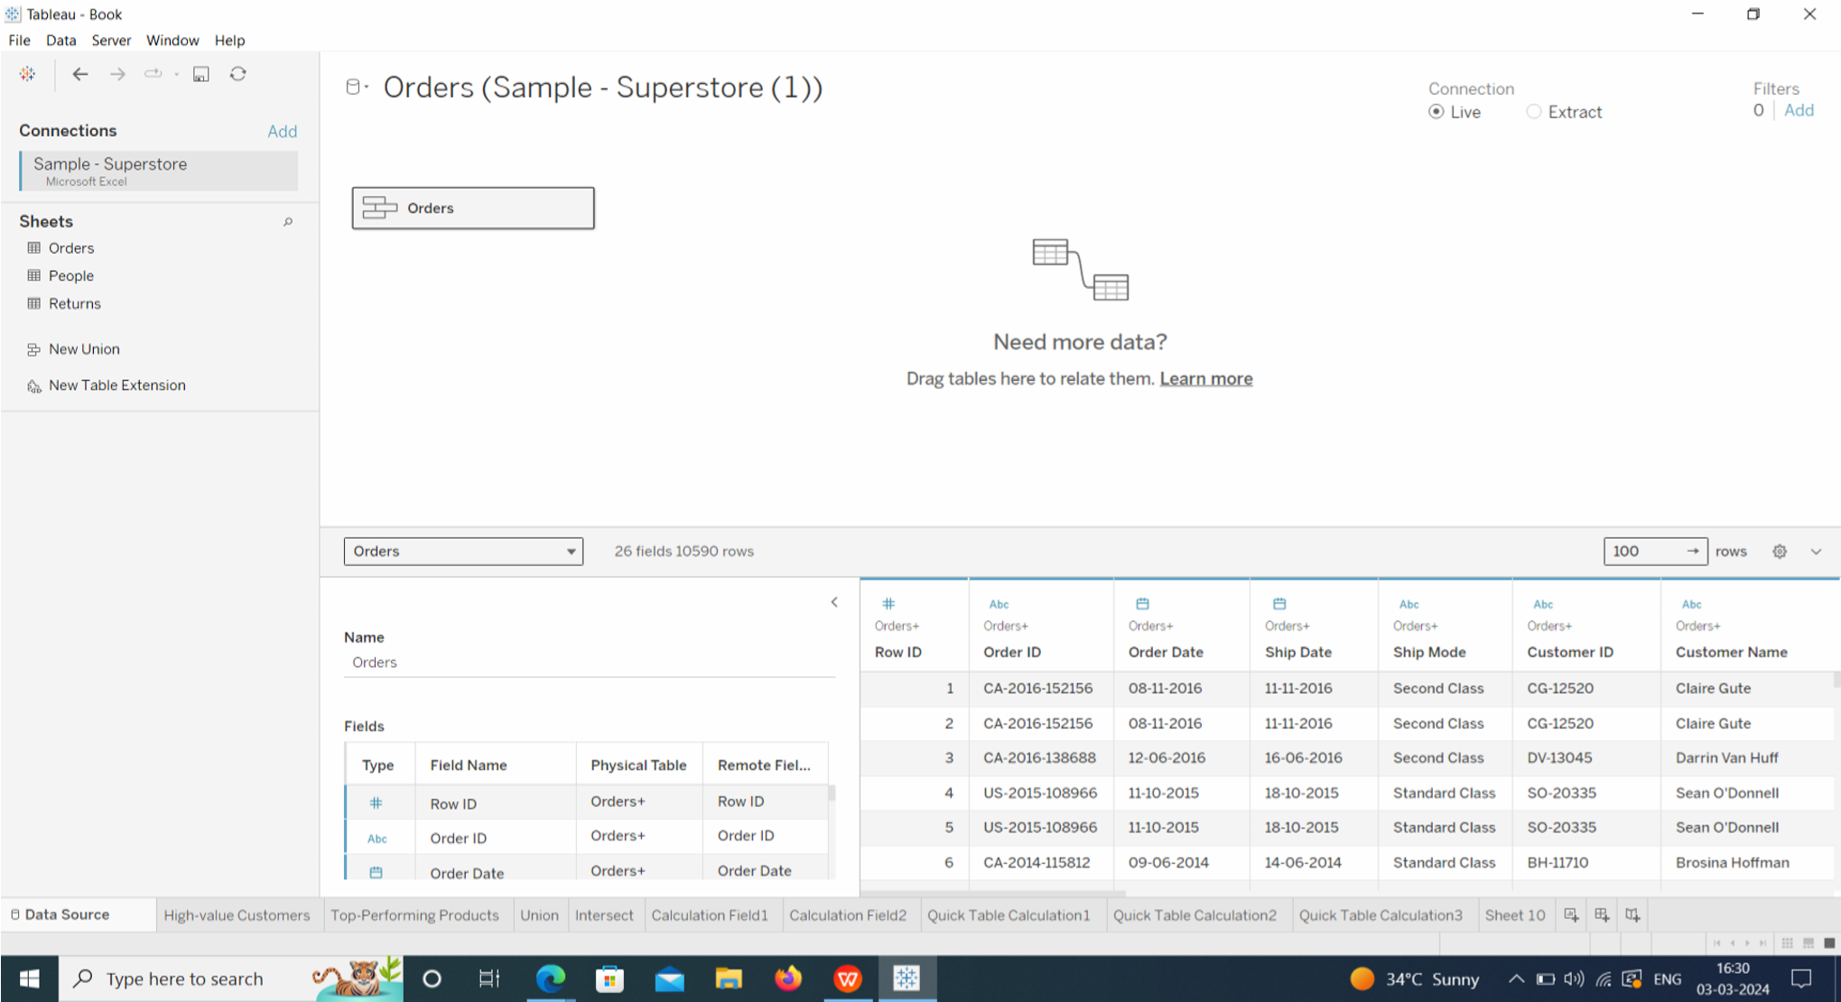

Create One Fixed LOD Expression and one exclude LOD expression:-

One Fixed LOD:-

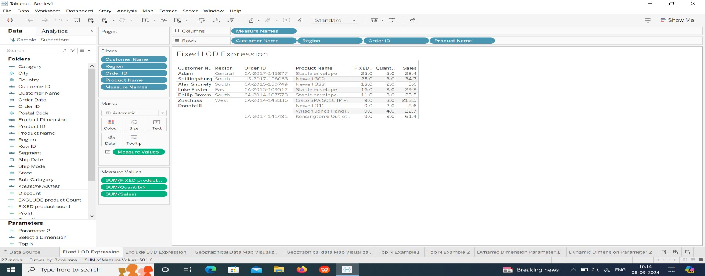

One Exclude LOD Expression:-

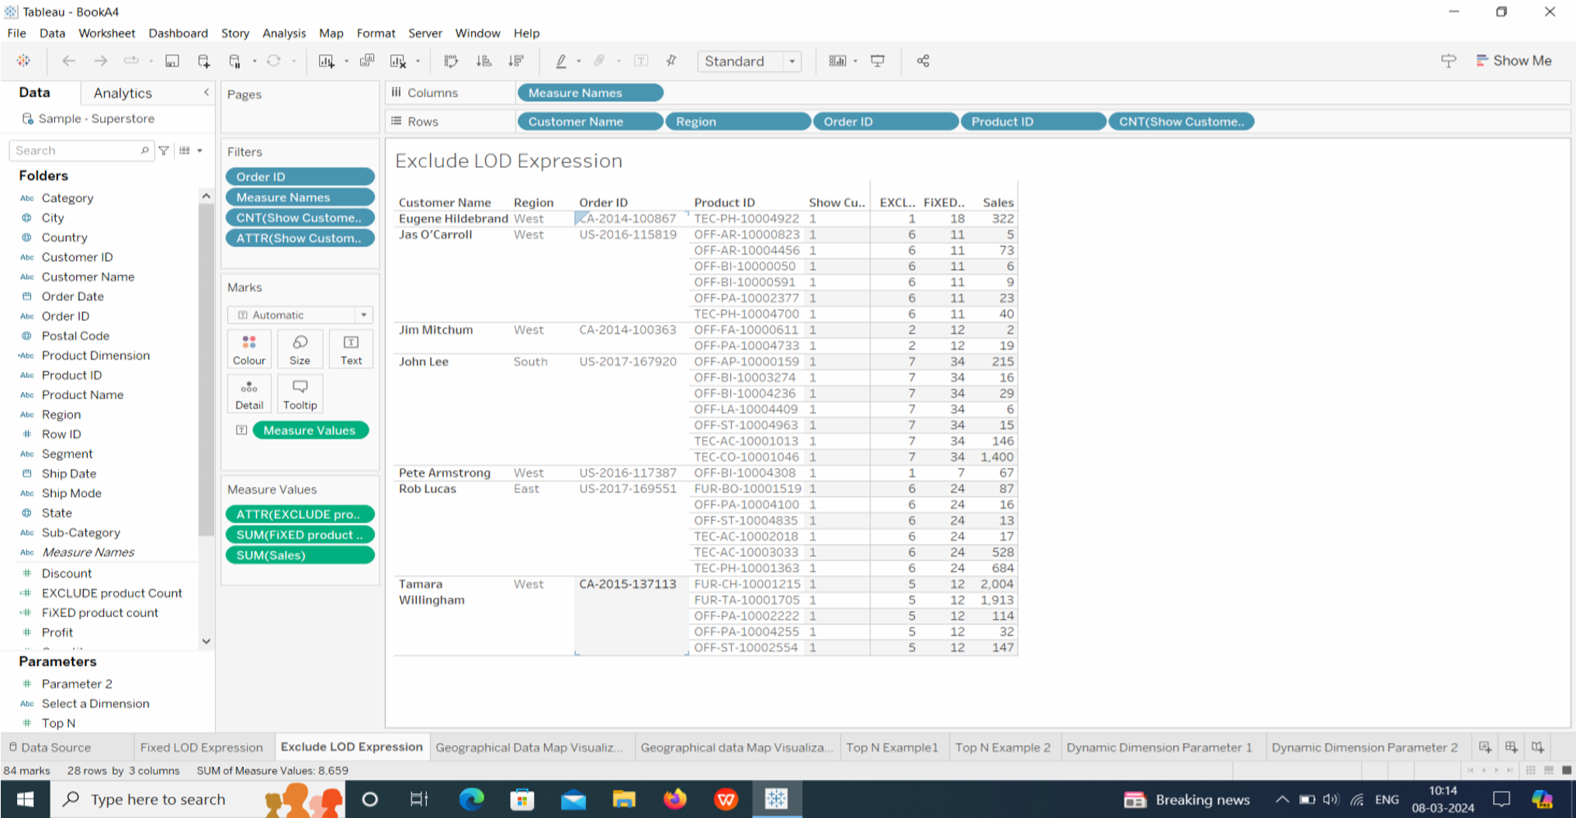

Create any 2 map visualizations using geographical data:- Map visualization 1:-

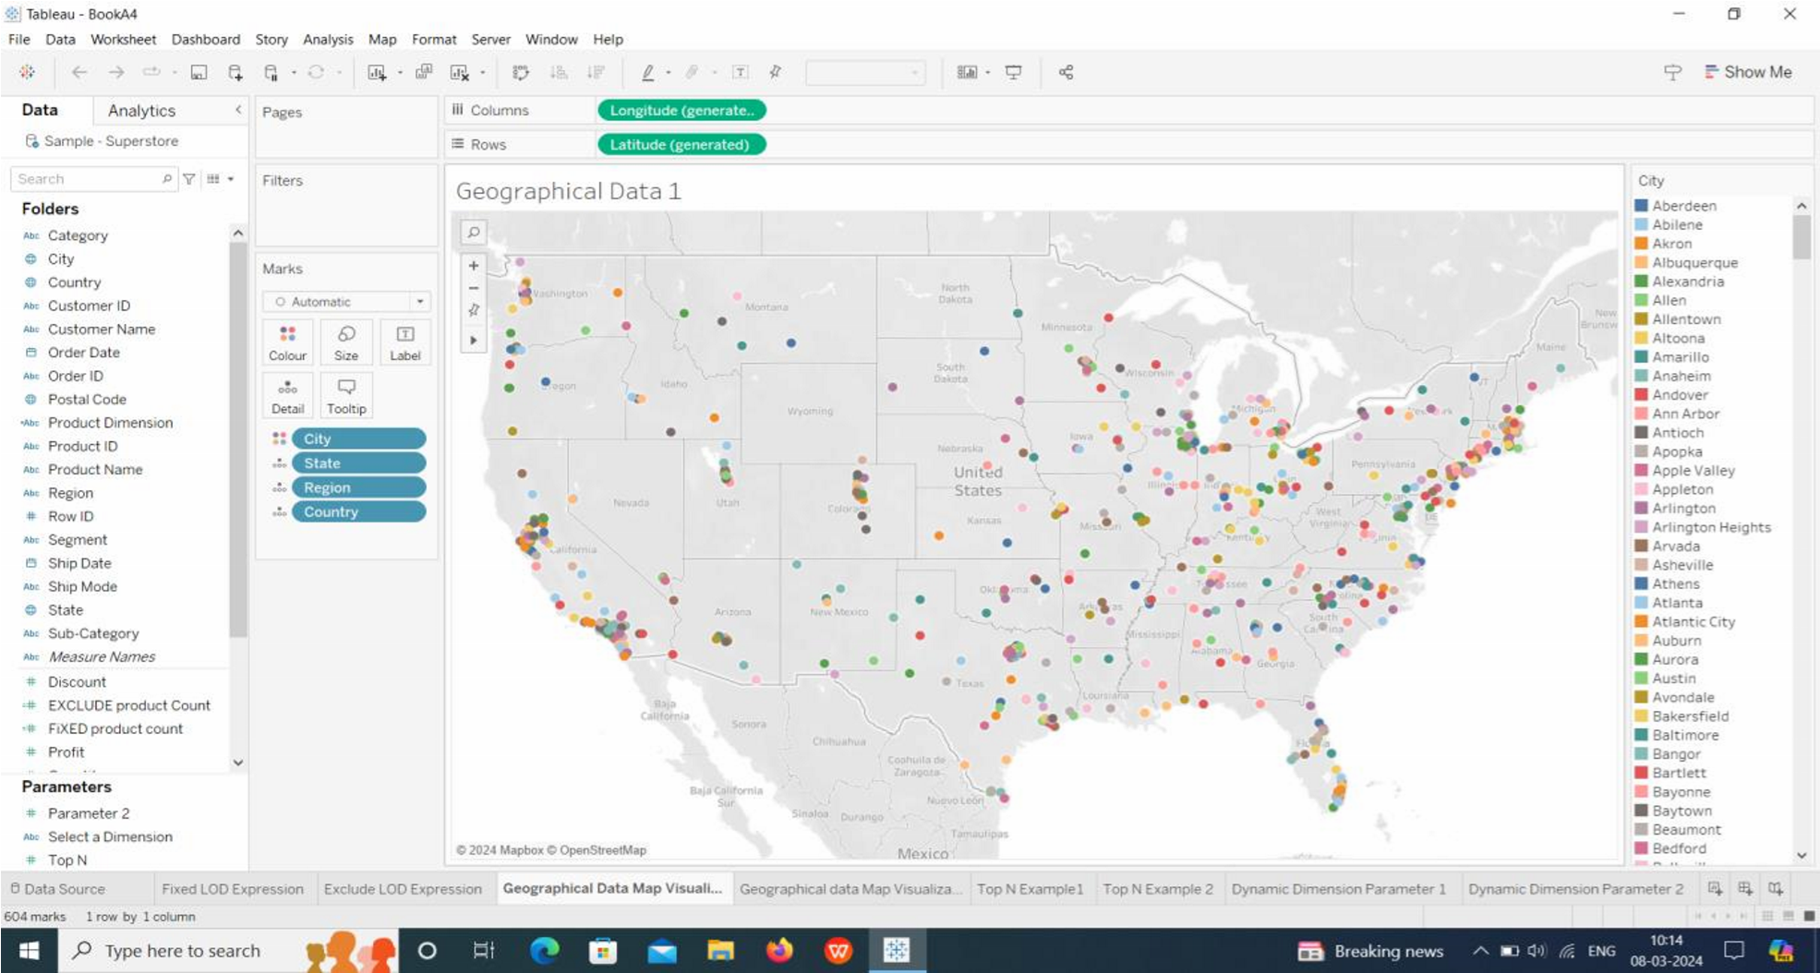

Map visualization 2:-

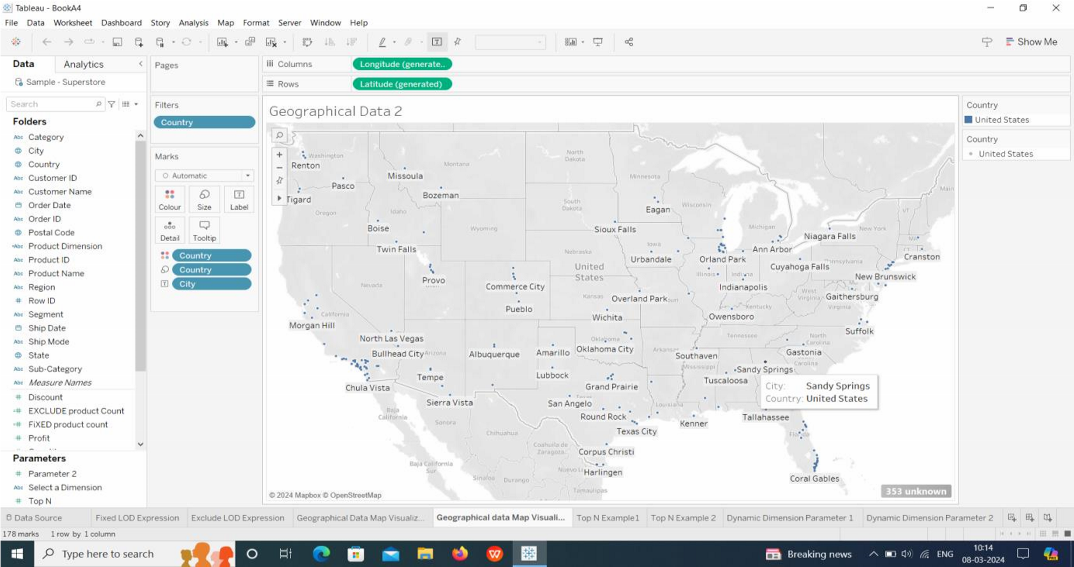

Create Top N and/or Dynamic dimension parameters and utilize those in your workbook:-

Top N Parameters:-

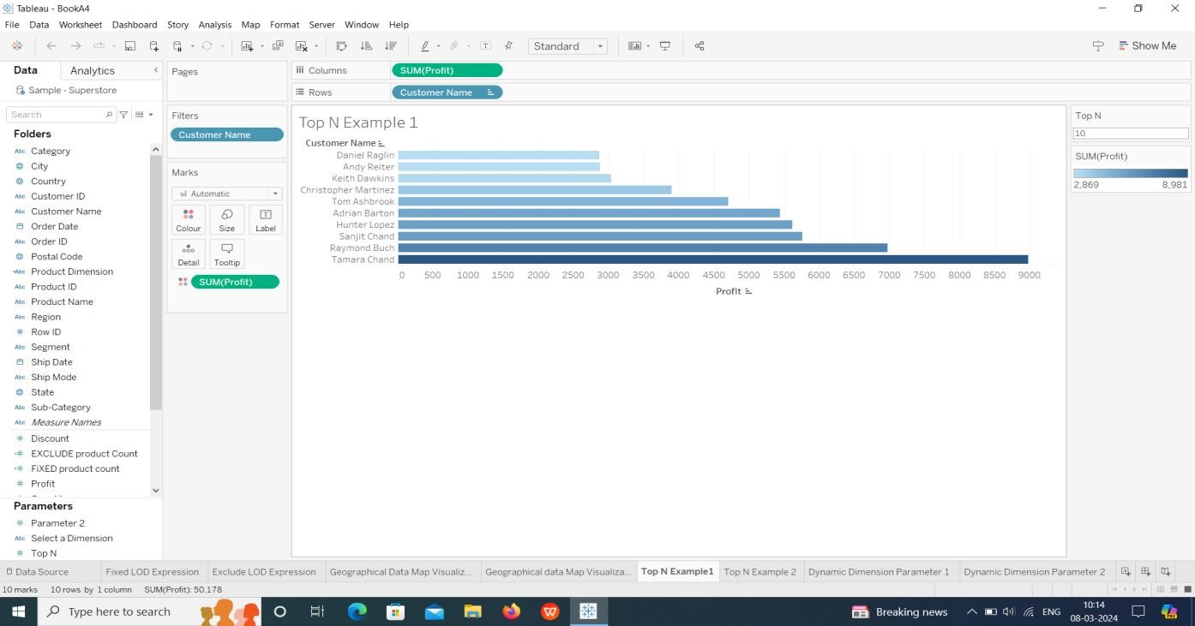

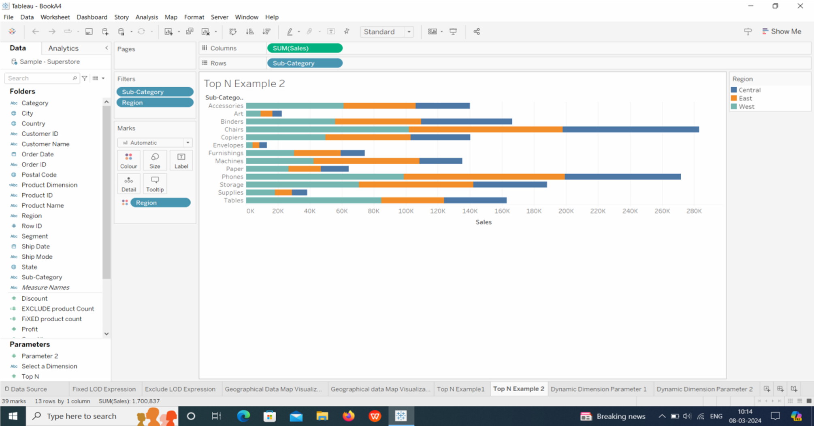

Dynamic Dimension Parameter 1:-

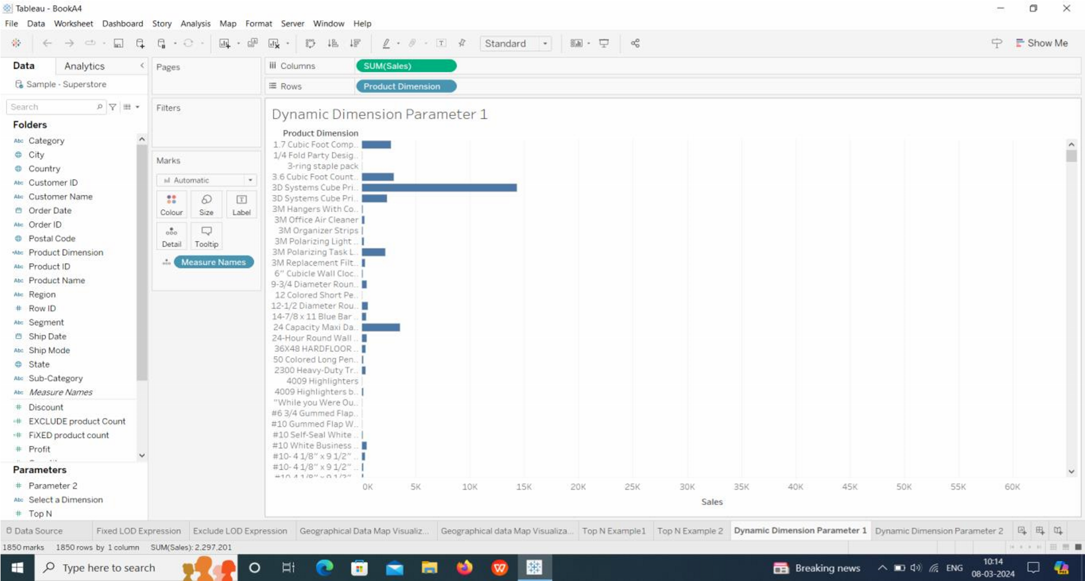

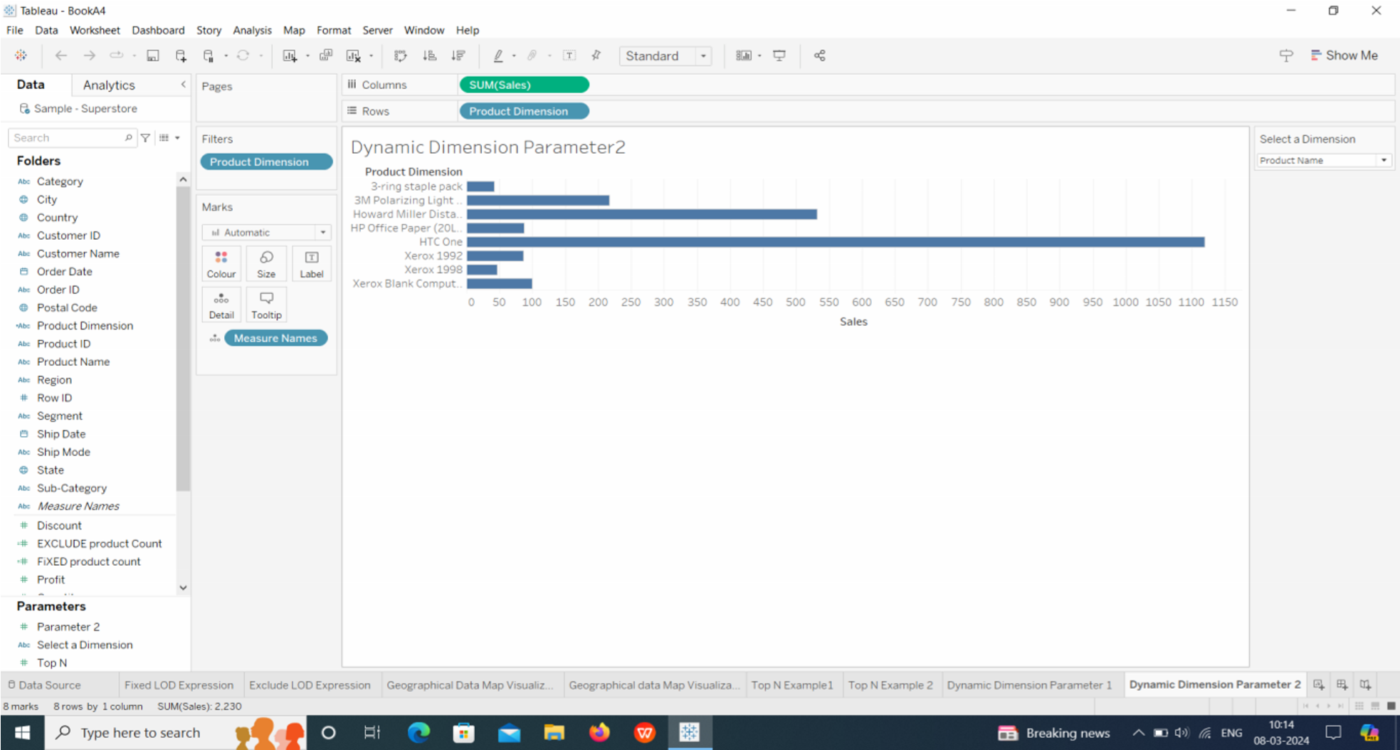

THANK YOU!

Email:-shaikreshma1508@gmail.com